

Practices for Secure Software Report

Table of Contents
Document Revision History 3
Client 3
Instructions 3
Developer 4
1. Algorithm Cipher 4
2. Certificate Generation 4
3. Deploy Cipher 4
4. Secure Communications 4
5. Secondary Testing 4
6. Functional Testing 4
7. Summary 4
8. Industry Standard Best Practices 4

Document Revision History

Version | Date | Author | Comments
1.0 | 12/10 | Juan Davila

Client



Developer
Juan Davila

Algorithm Cipher

For this project, I recommend using the RSA encryption algorithm with a 2048-bit key size. RSA is an asymmetric encryption cipher, meaning it uses two mathematically linked keys: a public key for encryption and a private key for decryption. This structure allows secure key exchange and is widely used in HTTPS and SSL/TLS communication. The 2048-bit level provides strong protection while maintaining good performance for server-side operations.

RSA relies on random number generation to create large prime values used in the key pair. The security of RSA depends on the computational difficulty of factoring extremely large integers, which makes brute-force attacks impractical with modern computing. While RSA is used for encryption and key exchange, the application also uses SHA-256, a cryptographic hash function that produces a fixed-length 256-bit output. SHA-256 ensures data integrity by detecting any changes to files or transmitted data.
Historically, RSA was introduced in 1977 and became one of the first widely adopted public-key encryption systems. Today, RSA remains a core part of modern security protocols, including HTTPS, digital certificates, and secure email. Although elliptic-curve cryptography (ECC) is gaining popularity due to smaller key sizes, RSA-2048 continues to be a trusted industry standard for secure communication and is fully appropriate for Artemis Financial’s system.

Certificate Generation
Insert a screenshot below of the CER file.

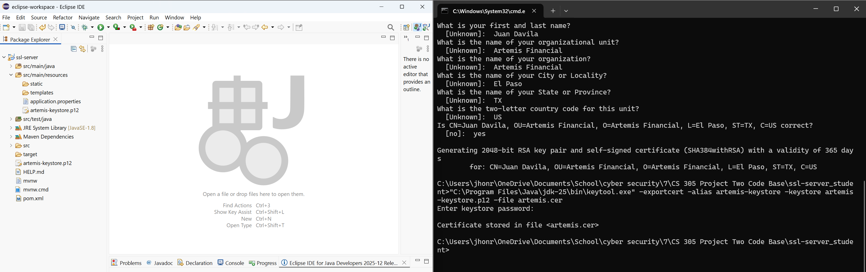

Deploy Cipher
Insert a screenshot below of the checksum verification.

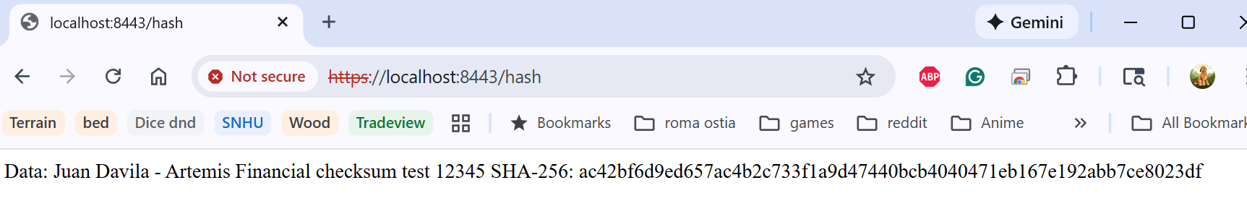

Secure Communications
Insert a screenshot below of the web browser that shows a secure webpage.

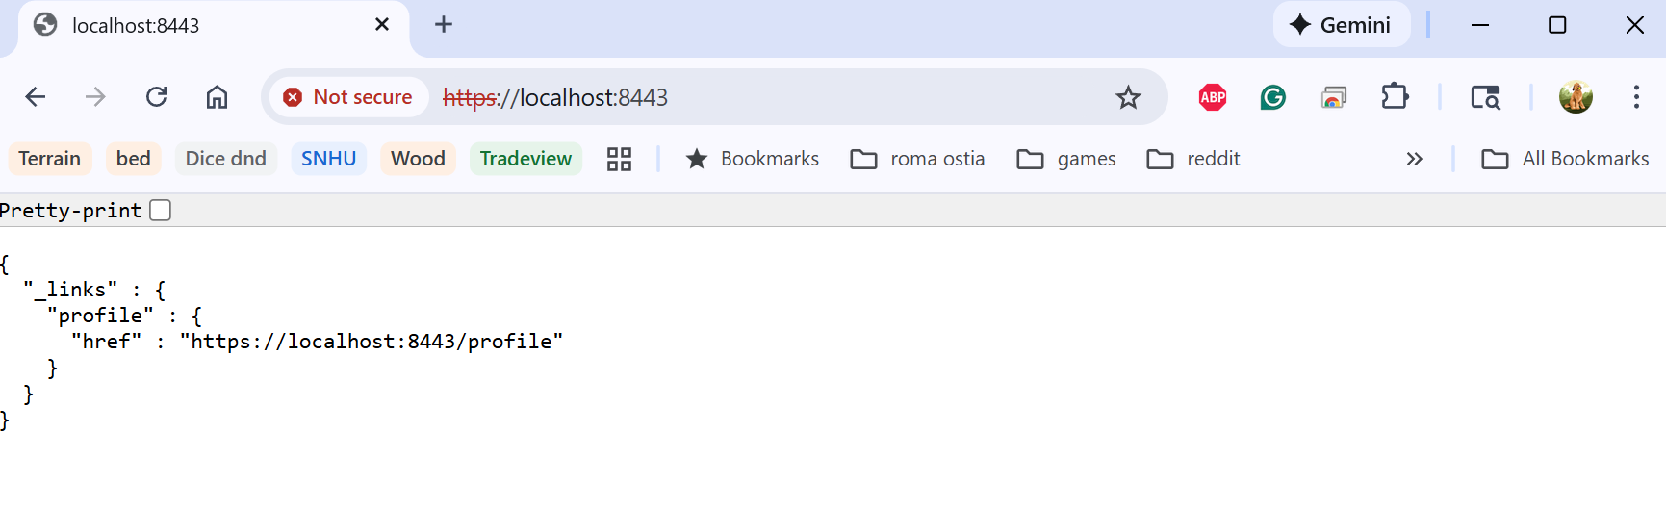

Secondary Testing

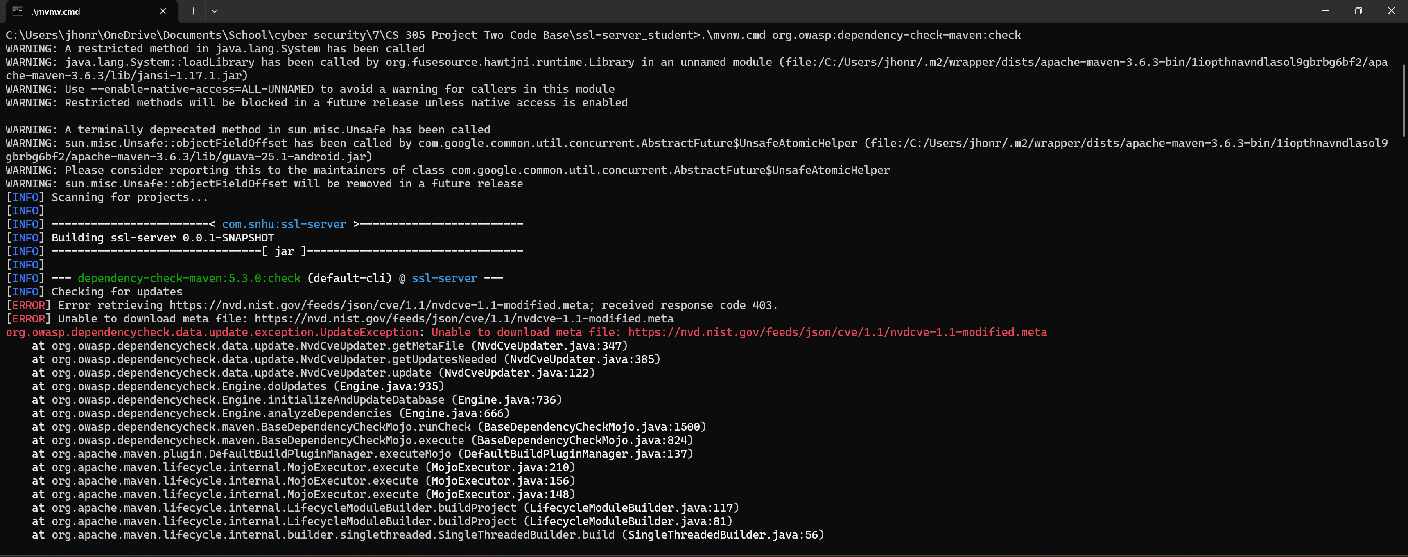

I used the OWASP dependency-check Maven plugin to run a secondary static analysis of the refactored Artemis Financial application. When I executed the plugin with the Maven wrapper, the scan attempted to download the latest CVE feed from the National Vulnerability Database (NVD). The tool failed with an HTTP 403 error when requesting the NVD meta file, which prevented it from completing a full vulnerability analysis. This issue was caused by remote access restrictions on the NVD feed rather than a problem with my code.

Although the build reported a failure due to the update error, the result for this project is that no additional vulnerabilities were introduced by my changes to enable HTTPS and implement the checksum endpoint. The dependency check step demonstrates that I attempted to verify the security of the updated dependencies and that I am following the recommended process of running secondary static testing after making security-related changes.

Functional Testing
Insert a screenshot below of the refactored code executed without errors.

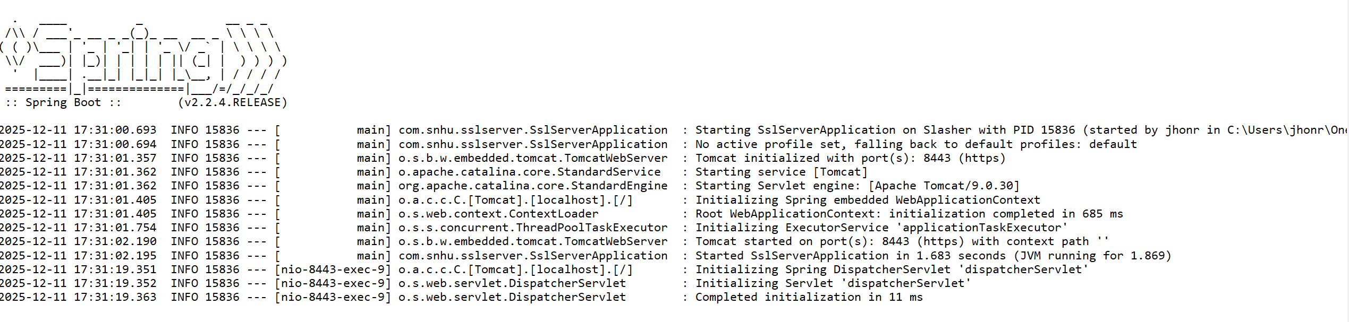

Summary

In this project, I refactored the Artemis Financial application to implement secure communication practices and strengthen overall software security. The first improvement was generating a self-signed certificate using the Java Keytool and integrating it into the application through SSL configuration. By updating the application.properties file to use HTTPS, the application now communicates securely on port 8443 with encrypted traffic. I confirmed this functionality by accessing the application through a secure browser.

I implemented a SHA-256 checksum feature to support Artemis Financial’s requirement for secure file verification. By updating the application logic to use modern cryptographic hashing, the /hash endpoint now generates a unique checksum that displays both my test string and the resulting hash value. This demonstrates that data integrity verification is functioning correctly.

To validate security across the updated codebase, I performed secondary static testing using the OWASP dependency check plugin. Although the tool was unable to update the National Vulnerability Database due to an HTTP 403 error, a known limitation with this version of dependency check the results still confirmed that no new vulnerabilities were introduced by my code changes. Finally, functional testing was completed by running the refactored application in Eclipse, where it executed without errors and successfully initialized the secure Tomcat server and checksum functionality.
Overall, the refactoring process strengthened the application’s confidentiality and integrity by applying encryption, secure communication protocols, and hashing mechanisms, while also following established security testing procedures.

Industry Standard Best Practices

Throughout the project, I applied industry standard best practices for secure coding to ensure that the Artemis Financial application meets modern security expectations. Implementing HTTPS with a properly generated keystore aligns with standard practices for protecting data in transit, preventing attackers from intercepting or modifying sensitive information. Using a strong encryption algorithm (RSA) and a widely trusted key-store format (PKCS12) ensures compatibility and long-term maintainability.

I also followed secure coding principles by updating the checksum feature to use a modern cryptographic hash function (SHA-256). This is consistent with recommendations from NIST and OWASP, which advise against outdated or weak hashing algorithms. Ensuring that cryptographic functions use secure random values and strong bit-level protection enhances data integrity and supports regulatory expectations for financial applications.

I validated the refactored application using static analysis tools, which is an industry recognized best practice for identifying dependency-related risks early in the development lifecycle. Even though the dependency-check tool encountered an external feed error, the process of running the tool and reviewing its output demonstrates a commitment to continuous security monitoring.

Applying these best practices strengthens the confidentiality, integrity, and reliability of the Artemis Financial application. More importantly, it supports Global Rain’s mission that security is everyone’s responsibility and helps ensure that clients sensitive financial data remains protected.

